**Assignment 4**

1. Pull an Image from docker hub and run it in docker playground.

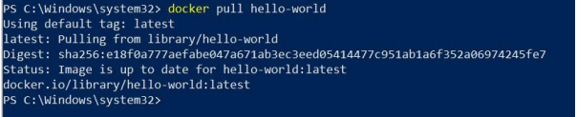

1. Create a docker file for the job portal application and deploy it in Docker Desktop Application.

helloworld:

latest

WORKDIR

~/Desktop/

ADD .

helloworld/

WORKDIR

~/Desktop/htmlfile

RUN pip install -r

requirements RUN

chmod +x app.sh

CMD["/bin/sh","app.s"]

1. Create an IBM container registry and deploy helloworld app or Job portal app.

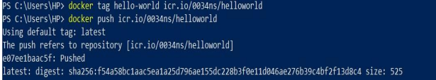

1. Create a Kubernetes cluster in IBM cloud and deploy helloworld image or job portal image and also expose the same app to run in node port.

